**LOMBA KOMPETENSI SISWA**

**SEKOLAH MENENGAH KEJURUAN**

**TINGKAT PROVINSI KALIMANTAN TENGAH TAHUN 2021**

|  |
| --- |
| **NASKAH SOAL**  **(Terbuka)** |

**Bidang Lomba**

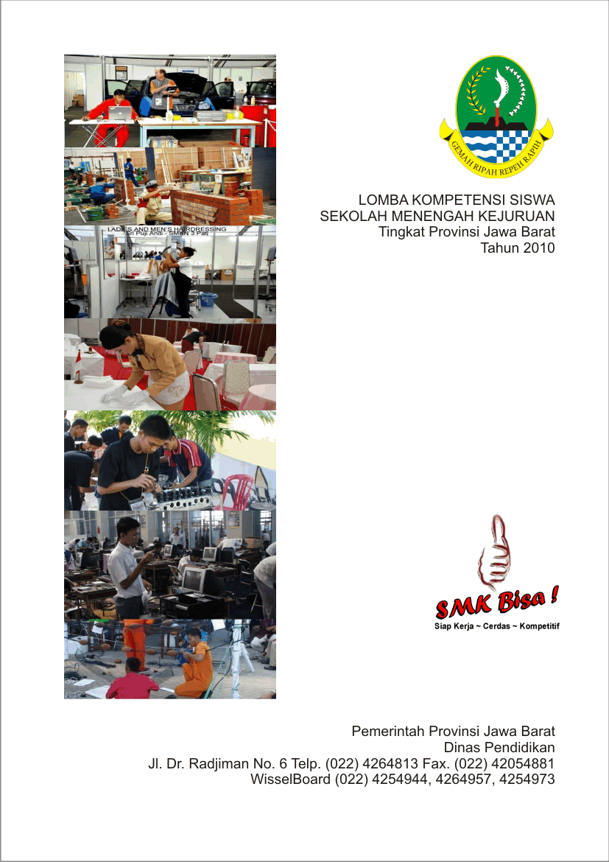**WEB TECHNOLOGIES**

|  |
| --- |
|  |

## MODULE CLIENT

### Contents

**This module has the following files:**

* MODULE_CLIENT.doc
* MEDIA FILES.zip

### Introduction

BAMRI ask you to make a minimum viable product for driver and bus scheduling system. Your task is to implement the backend with Laravel PHP Framework and interactive frontend JavaScript frameworks to consume the backend API. There are 3 provided frameworks: Vue.js, React.js, and Angular.js. Use one of the provided frameworks in working on this module. The detail description and tools that you can use will be described below.

### Description of project and tasks

The complete BAMRI system should cover the following requirement:

|  |  |
| --- | --- |
| **Menu** | **Detail** |
| Login | * The user can login (and logout) into the system on the start page of the application * After login, user have access to “bus”, “driver”, and “order” menu * Links to the authorized menu and logout link are always visible on the top part of the page while the user is logged in * Make sure your system is preventing users to access unauthorized menu * There must be no register feature available |
| Bus | * On “bus” menu, user can add new bus * User can update and delete existing bus * All input form is must be **filled** on **create** * **Plate** **Number** must be a *string* * **Brand** must be between *mercedes / fuso / scania* * **Seat** must be *integer* and *more or equals 1* * **Price per day** must be *integer* and *more or equals 100.000* |
| Driver | * On “driver” menu, user can add new driver * User can update and delete existing driver * All input form must be **filled** on **create** * **Name** must be a *string* * **Age** must be *integer* and *more or equals 18* * **ID Number** must be a *string* and *consists of 16 character* |
| Order | * On “order” menu, user can add new order * User can update and delete existing order * All input form is must be **filled** on **create** * **Contact Name** must be *string* * **Contact Phone** must be *string* and *digits* * **Start Rent Date** must be *date* and *minimum date is tomorrow* * **Total Rent Days** must be *integer* and *more or equals 1* * The system will match available bus with available driver. * No bus and driver rent time can’t be **overlap** with other order. |

### Instructions to the Competitor

* Save your files in your root directory on the server called "**XX_MODULE_CLIENT**"  
  where XX is your computer number.

## For this module, you must use one of the three available frameworks provided. Applications developed without use of any of these frameworks will not be considered. You should take advantage of the framework as much as possible.

## Assessment will be done on the files and data in your database “XX_MODULE_CLIENT"